

BAHIR DAR INSTITUTE OF TECHNOLOGY
DEPARRTMENT OF COMPUTER ENGINEERING

Introduction to Control and Instrumentation

project

NAME ID
- Melaku Zegeye 1203552
- Biruk Aynalem 1201260
- Elleni Alebachew 1201520
- Ermiyas Desalegn 1201520
- Betelhem Molla 1207808
- Nurahmed Jibril 1202702

Submitted to Mr. Desale A
Submitted date 28/02/2023

Title
Development of automatic street light control system

Abstract

The existing lighting control system was developed uniquely for the target center at the time of construction and is a one of a kind system. Our country is suffering from power crisis for a long time. Although some times because of our ignorance, we see street lights are on in the day. So we always suffer from this electricity crisis. By using automation to our street lights controlling system we can not only save our energy but also save human labor. Here we will show how we can make a controlling system easily by using LDR and Relay and small amount of power supply. The present system is like, the street lights will be switched on in the evening before the sun sets and they are switched off the next day morning after there is sufficient light on the roads. As a result the electricity waste occurs greatly all over the country. But the actual timings for these street lights to be switched on are when there is absolute darkness. This project gives the best solution for electrical power wastage. Also the manual operation of the lighting system is completely eliminated. In our project we are using LDR, which varies according to the amount of light falling on its surface, this give an indication for us whether it is a day/night time. Bridge type full wave rectifier is used to rectify the ac output of secondary of 230/12V step down transformer. We believe that our idea provides better than the existing system. In the present project street lights are taken into consideration where the above discussed factors are rectified in them. The main aim of the project is to save the power; by using effectively we can save more power, as we know that there is shortage of power nowadays in every where mostly in villages Nowadays, human has become too busy and he is unable to find time even to switch the lights wherever not necessary. This can be seen more effectively in the case of street lights. the actual timings for these street lights to be switched on are when there is absolute darkness. This type of regulation is ideal for having a simple variable bench power supply. Actually this is quite important because one of the first projects a hobbyist should undertake is the construction of a variable regulated power supply. While a dedicated supply is quite handy e.g. 5V or 12V, it's much handier to have a variable supply on hand, especially for testing. Most digital logic circuits and processors need a 5 volt power supply.

Introduction

The Street lights are the major requirements in today’s life for safety purposes and avoiding accidents during night. Providing street lighting is one of the most important and expensive responsibilities of a city. Lighting can account for10-38% of the total energy bill in typical cities worldwide. Street lighting is a particularly critical concern for public authorities in developing countries because of its strategic importance for economic and social stability. The fixtures of street lights indirectly have assisted the public and government in reduction of crime rate and accidents in the area. It also encourages social inclusion by providing an environment in which people feel they can walk in hours of darkness. Despite that in today’s busy lifestyle no one bothers to switch it OFF/ON when not required. Inefficient lighting wastes significant financial resources each year, and poor lighting creates unsafe conditions. Energy efficient technologies and design can cut street lighting costs dramatically. Basic purpose of this project is to make street lights intelligent so that it can turn it on and off itself.
Street lights turns itself on automatically during night or darkness. They turn themselves of automatically during day time and during visible intensity of light. Street lights controls its intensity automatically according to intensity of light. For example, in evening intensity of light start decreasing at the same time street lights start increasing its intensity. When there is no intensity of light in after evening, street lights turn themselves on with full intensity till midnight at 12:00 am. Basically the circuit is based on IC LM358 which is an operational amplifier that is configured as a comparator, LDR whose resistance is based on quantity of light falling on it and it is the main component to sense the light. The relay which fills the gap between what it receives, which is a DC signal and allows the device to operate with AC and also controls large amount of current and voltage with small electrical signal. There are also different components like transistor, resistors, battery, LED

Statement of problem
The main purpose of this project “automatic street light control” is to minimize the cost & loss of electricity and also man power to manually on- off the street light.
Manually the street lights are being on and off by someone at night and day, though when the weather is cloudy the light to see each other and for vehicle too is so hard, then we need lights which can control it self automatically.
Having this problem in mind, this project tries to overcome the problem using a light sensor.

Scope and Limitation
In his project we developed a simulation program for street lights that glows in a less light intensity. Here the primary goal is to limit the street lights energy consumption. Those street lights should be automatically turned ON or OFF using LDR sensors that will detect the environmental light intensity and take action to operate the street lights. The practical application of our project is not limited to any specified country or person, since the cloudy weather happens to every country and fearing for one's self safety is everyone's problem.

Significance

The significance of the project is to deliver street light to everyone with savings of energy and power. We can also reduce money cost by using LDR and relay. The street lighting system is very easy to made. We can make it providing low cost and a few labor. It’s saves a huge amount of power and energy for us.

Objective

General Objective
To design and simulate automatic street light control system using light dependent resistor
Specific objectives
To study the existing street light control systems.
To design energy efficient street light control System.
To develop the hardware of control unit.
To test and validate the designed system.

Materials required
LDR
A device whose sensitive depends on intensity of light falling on it. When strength of light falling on it increases the LDR resistance decreases which is almost zero, while the strength of the light falling on it decreases, its resistance will be increased.
Before mounting on the component, we should check whether the component works properly or not.
For testing LDR set the range of multimeter in resistance measurement, the amount of resistance should be low for high or bright light. And its resistance should be high for low or dim light.
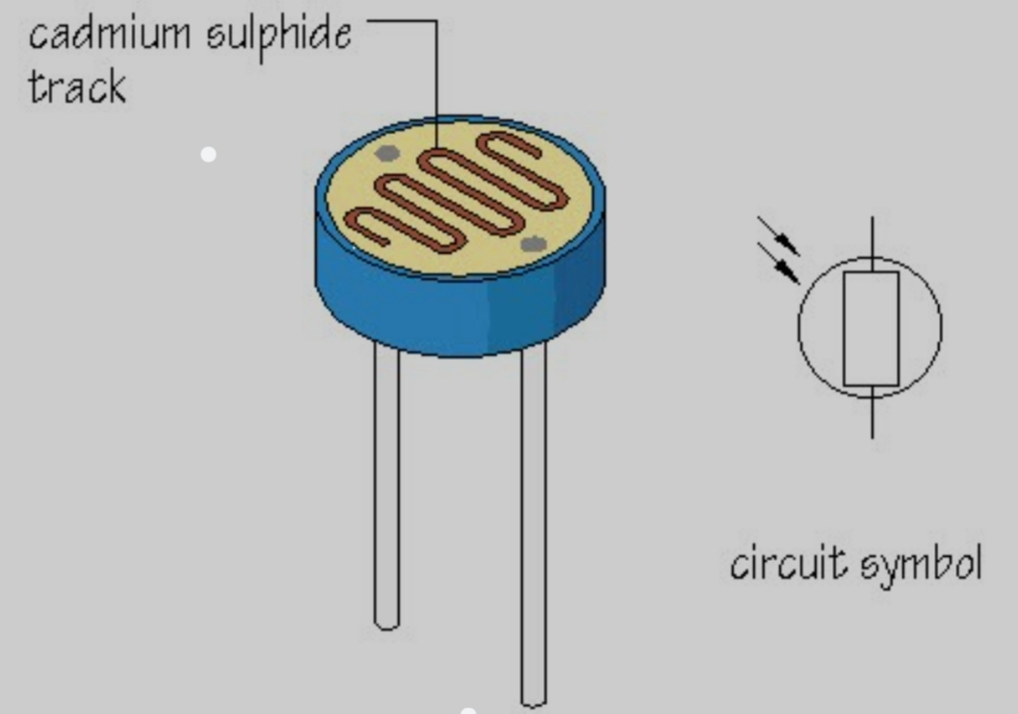

Resistors
A passive component having two terminals that is used to mannage the current flow in the circuit. The current that flows via a resistor is directly proportional to the voltage that appears across the resistor.
Those are two types fixed having fixed value and variable resistors having variable resistance calculated with the help of multimeter.
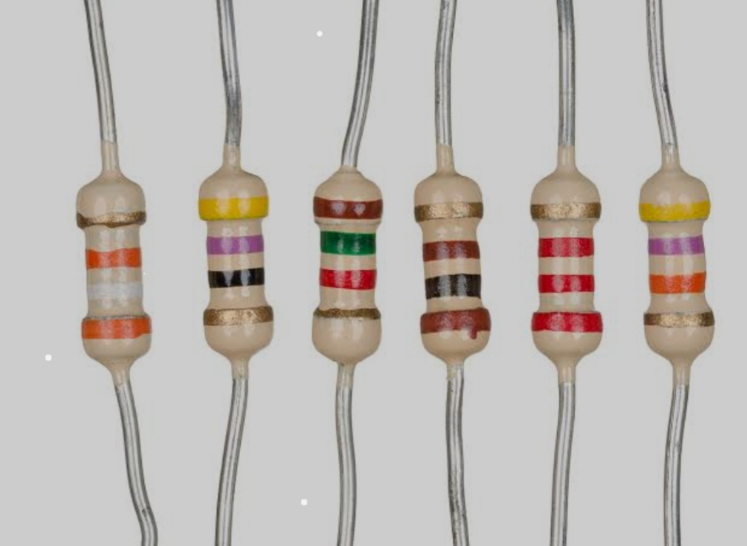

Relay
Provides isolation between the controller and device because the device may work on AC or DC but the relay receives signals in DC so we need relay to bridge the gap. There are factors to select appropriate relay these are the maximum voltage which will acquired in the output Amount of contacts in the armature
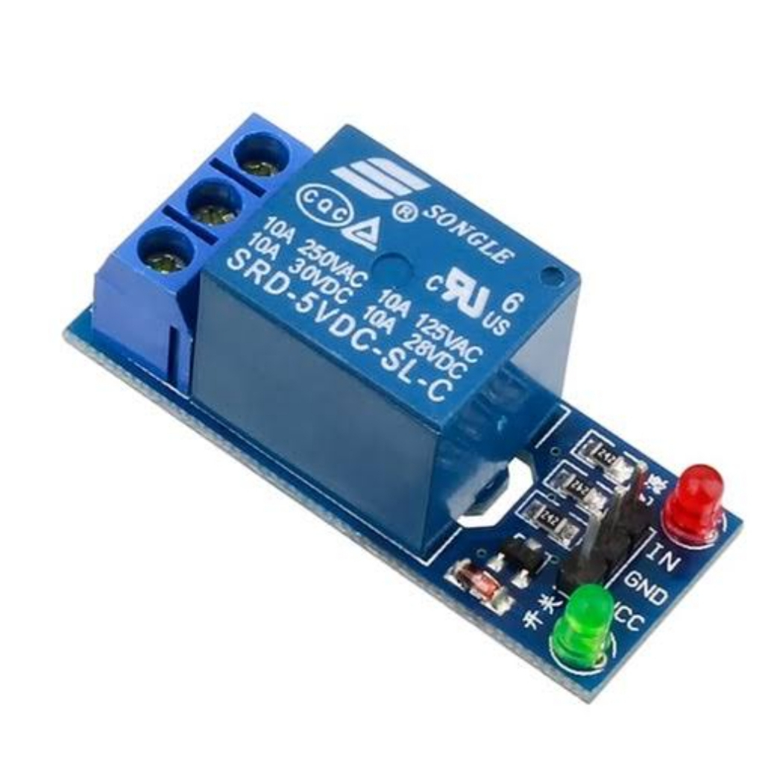
The number of electrical associates (normally close and open)

The relay's switch connections are usually labelled COM, NC and NO:
COM = Common, always connect to this; it is the moving part of the switch.
NC = Normally Closed, COM is connected to this when the relay coil is off.
NO = Normally Open, COM is connected to this when the relay coil is on.
Connect to COM and NO if you want the switched circuit to be on when the relay coil is on.
Connect to COM and NC if you want the switched circuit to be on when the relay coil is off.

Voltage regulator
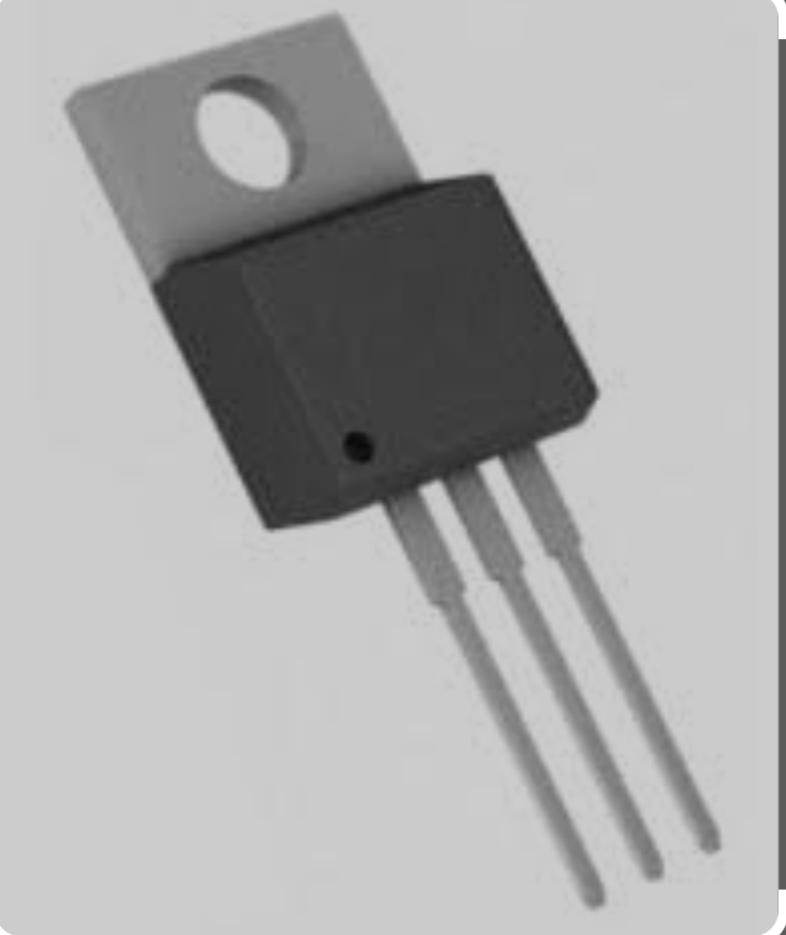
A voltage regulator is a system designed to automatically maintain a constant voltage. A voltage regulator may use a simple feed-forward design or may include negative feedback. It may use an electromechanical mechanism, or electronic components. Depending on the design, it may be used to regulate one or more AC or DC voltages

LED or LAMP
Light emitting diode a component that allows electricity in one way. LED have two connections anode and cathode. The current flows from anode to cathode.
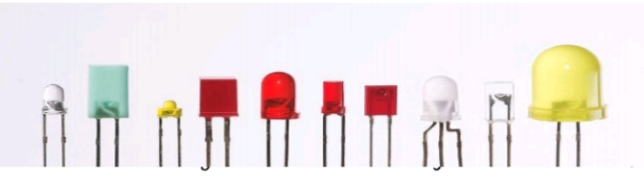

Transistor
A semiconductor, which conducts electricity in a "semi-enthusiastic" way, falls somewhere between a real conductor like copper and an insulator such as the plastic wrapped around wires). Although most transistors are made from silicon (Si), they can be made from other materials. A transistor's three-layer structure contains one of the following layers
- an n-type semiconductor layer between two p-type layers in a positive-negative-positive (PNP) configuration; or
- a p-type layer between two n-type layers in a negative-positive-negative (NPN) configuration

A transistor is like a set of two diodes with their cathodes or anodes tied together. It has three terminals that carry electrical current and help make a connection to external circuits:
- the emitter, also known as the transistor's negative lead,
- the base, which is the terminal that activates the transistor, and
- the collector, which is the transistor's positive lead.

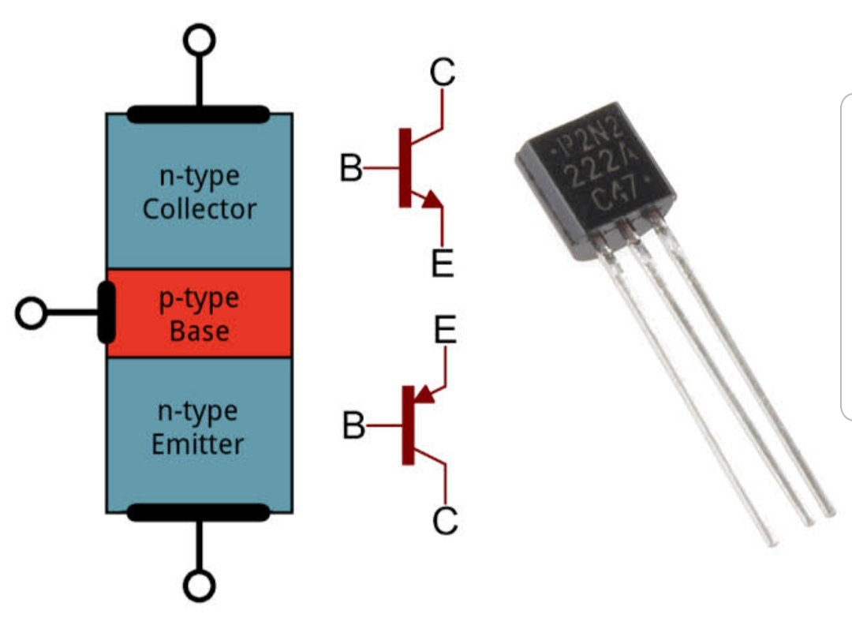

Diode
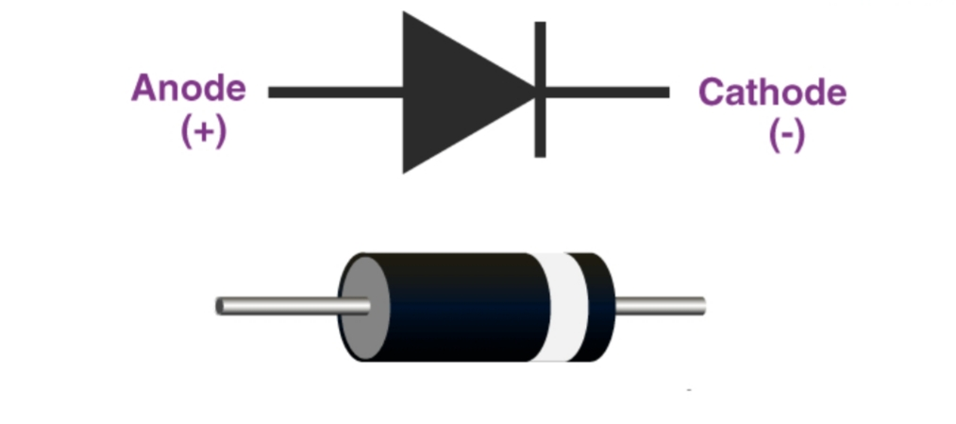
A diode is a semiconductor device that essentially acts as a one-way switch for current. It allows current to flow easily in one direction, but severely restricts current from flowing in the opposite direction.

Capacitor
Capacitors are simple passive device that can store an electrical charge on their plates when connected to a voltage source. And we use the capacitor to reduce the ripple effect that come from the full bride rectifier.
Jumper wires
Wires used for connection in a circuit.
Transformer
A transformer is an electrical device that uses the principle of electromagnetic induction to transfer energy from one electric circuit to another. It is designed to either increase or decrease AC voltage between the circuits while maintaining the frequency of the current. It can be either step up or step down transformer. In this project we use step down transformer which makes the output voltage less than the input one, el which is
Potentiometer
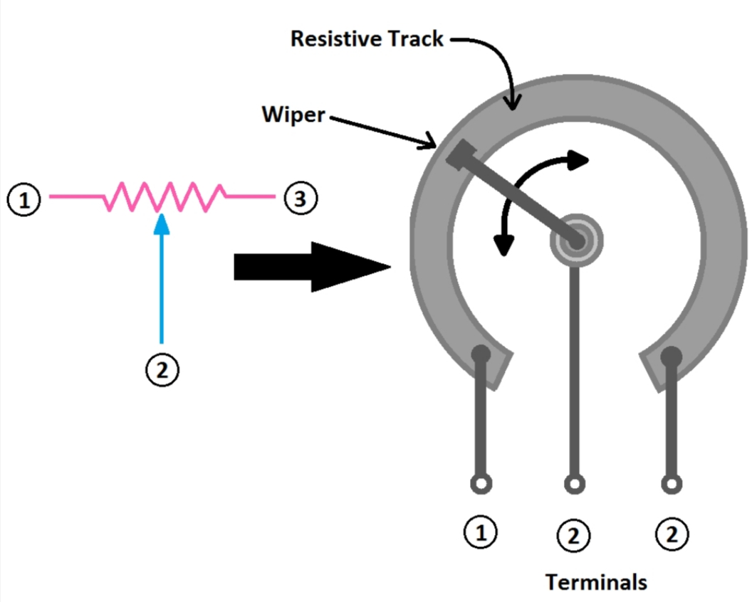
A potentiometer is a manually adjustable, variable resistor with three terminals. Two terminals are connected to the ends of a resistive element, the third terminal is connected to an adjustable wiper. The position of the wiper sets the resistive divider ratio.

Full Bridge rectifier
A full wave rectifier converts the input waveform to one of constant polarity, as opposed to a half-wave rectifier which only passes one half cycle while blocking the other.

Methodology
The street light control system adopts a dynamic control methodology.
Collecting of reference books and project papers relevant to our project
Drawing a circuit diagram by using proteus software
Writing a simulation program in micro proteus software
Running the project simulation using proteus software

The sensing component in this project is LDR. So, when any object is brought nearer to the LDR, the light falling on it will be decreased that causes its resistance to be high and when the object is removed the light falling on it will increase and the resistance will be less.
When the LDR is covered with something or the light falling on it decreases, its resistance increases which may result in higher voltage drop on it. Which is V=I*R, this voltage will be the input to relay's signal end which causes the relay to act as a switch to make the LED on.
In reverse when the light falling on LDR is high or when it is day time, the resistance of LDR decreases it will almost have a zero voltage drop. The relay should get a signal from a sensor which have a voltage, but here since the resistance is almost zero V=I*R=0, the input signal to the relay don't offer voltage to relay so it will not make the LED on.
when current flows through the 10k resistor, causes potential difference (voltage) to develop. The magnitude of this voltage is given by Ohm’s law, V=IR. As the value of resistor is constant, the voltage across the resistor is directly proportional to the magnitude of current flowing, which in turn is directly proportional to the amount of light falling on LDR. We compare this voltage change (nearer the object, more is the voltage at 10K resistor / LDR) with a fixed reference voltage (Created using a potentiometer).
Here, LM358 IC (A comparator/Op-Amp) is used for comparing the sensor and reference voltages. The positive terminal of photodiode (This is the point where the voltage changes proportion to object distance) is connected to non-inverting input of Op-Amp and the reference voltage is connected to inverting input of Op-Amp.
The Op-Amp functions in a way that whenever the voltage at non-inverting input is more than the voltage at inverting input, the output turns ON. When light falls on the LDR sensor, we need LED to be turned off. So we adjust the potentiometer so as to make the voltage at inverting input more than non-inverting.
When the light at the LDR is low, the voltage drop increases and at some point the voltage at non-inverting input becomes more than inverting input, which causes OpAmp to turn on the LED.

In the same manner, when the light falling on the LDR sensor is high, the voltage at non-inverting input reduces and at some point becomes less than inverting input, which causes Op Amp to turn off the LED.
Flow chart of methodology

Understand The project concept and relevant theories
Review of past works , papers and journals
Circuit diagram design, write simulation

Run the project simulation
Check the result

Design in proteus

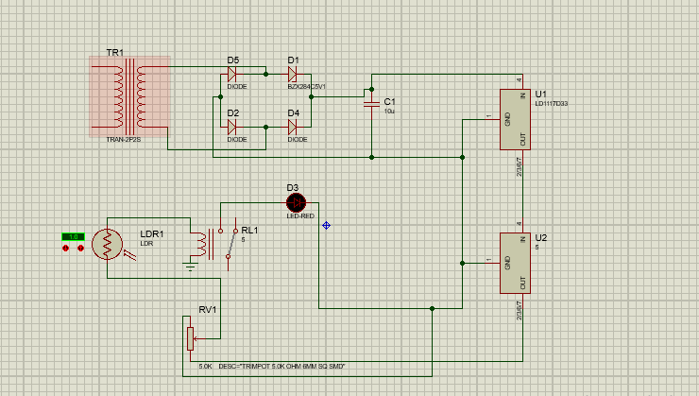

Demonstration
Sample from our work
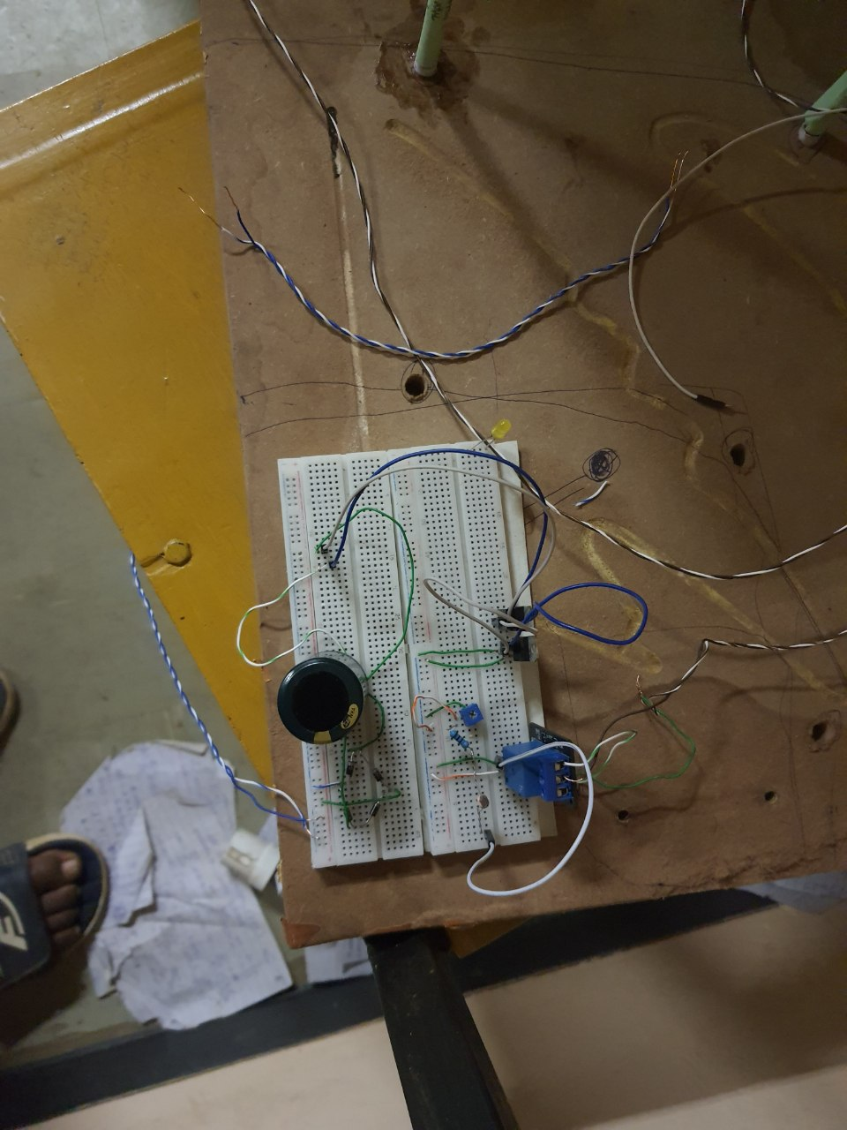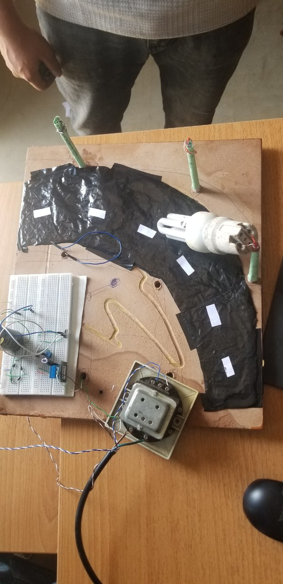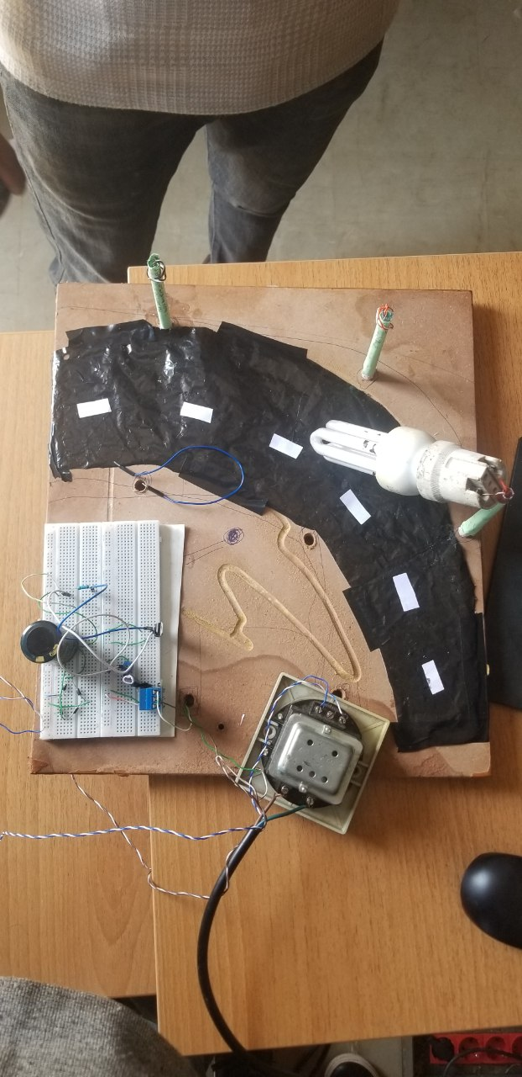

Summary
The main aim of the project is to save the power; by using effectively we can save more power, as we know that there is shortage of power nowadays in every where mostly in villages etc. So to overcome that we can provide street lights automatically with the centralized intelligent systems. So in future we can design many more advanced technologies to save power.
Here we are saving lot of power without any wastage, by these advanced technologies we can design many more systems which can be done by making it automatically control it self instead of doing it manually.

